**Summarizing Analysis Requested by Reviewers.**

1. **Follow-up Time for Statins and PPI using reverse Kaplan-Meier estimates.**

Table 1. Calculating follow-up time for Statins Cohort using reverse Kaplan-Meier estimates.

|  |  |  |  |  |  |  |
| --- | --- | --- | --- | --- | --- | --- |
|  | Statins Cohort | | | | | |
|  | PC Diag (n = 7553 total people in Statins Pcdiag Cohort) | | | PC Death (n = 2440 total people Statins Pcdeath Cohort) | | |
|  | Ovarll Statins | Hydrophilic Statins | Hydrophobic Statins | Overall Statins | Hydrophilic Statins | Hydrophobic Statins |
| N* (censured people) | 6698 | 2306 | 4392 | 686 | 155 | 531 |
| Mean (days) | 5454.822 | 5093.924 | 5603.601 | 1625.977 | 1573.126 | 1640.461 |
| Median (days) | 5577 | 5071 | 5755 | 1241 | 1142 | 1268 |
| Sd (days) | 1604.966 | 1694.034 | 1542.398 | 1435.897 | 1465.467 | 1427.449 |

N* (censured people: people who did not experience an event)

Table 2. Calculating follow-up time for PPI Cohort using reverse Kaplan-Meier estimates.

|  |  |  |  |  |  |  |
| --- | --- | --- | --- | --- | --- | --- |
|  | PPI Cohort | | | | | |
|  | PC Diag (n = 6972 total people in PPI PCDiag Cohort) | | | PC Death (n = 2409 total people in the PPI Pcdeath Cohort) | | |
|  | Overall PPI | PPI Other | PPI Panto | Overall PPI | PPI Other | PPI Panto |
| N* (censured people) | 6348 | 4402 | 1946 | 728 | 539 | 189 |
| Mean (days) | 5362.049 | 5415.409 | 5179.371 | 1625.258 | 1657.553 | 1495.967 |
| Median  (days) | 5498 | 5527 | 5338 | 1129 | 1152 | 1114 |
| Sd (days) | 1662.558 | 1599.525 | 1703.316 | 1500.717 | 1538.296 | 1332.425 |

N* (censured people: people who did not experience an event)

1. **Survival Analysis Results and Kaplan-Meier Survival Plots for Statins, Diabetes Medications and PPI’s.**

**Statins**

**Statins – OUTCOME: Diagnosis**

1. Univariable Analysis correcting for covariates.

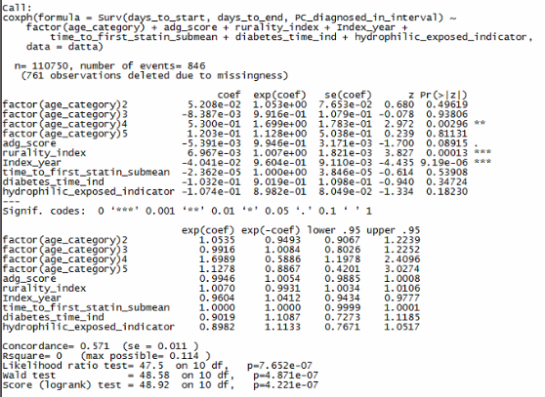

1. Multivariable Analysis.

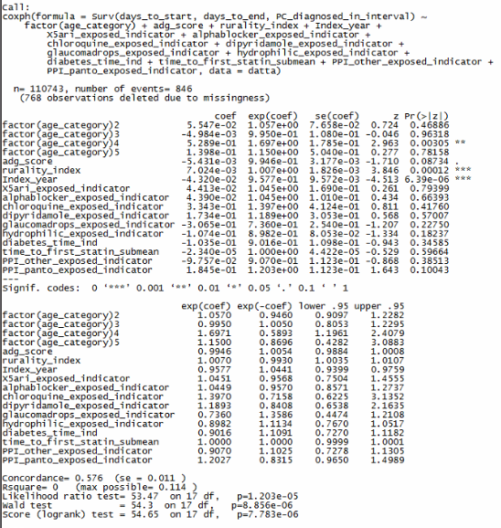

Fig 1. Survival Curve for the entire Statin Cohort

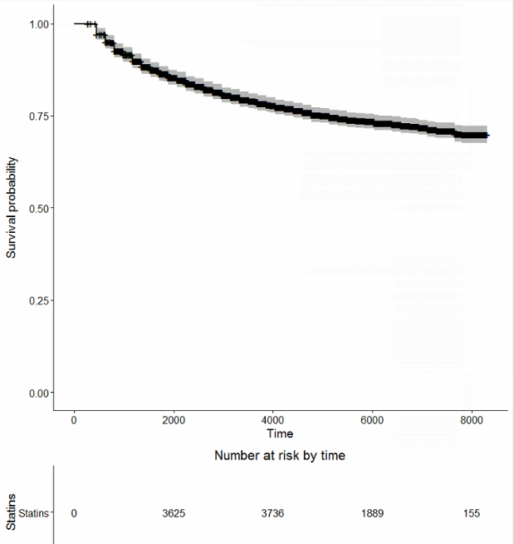

Fig 2. Survival Curve comparing the two Statins without CI

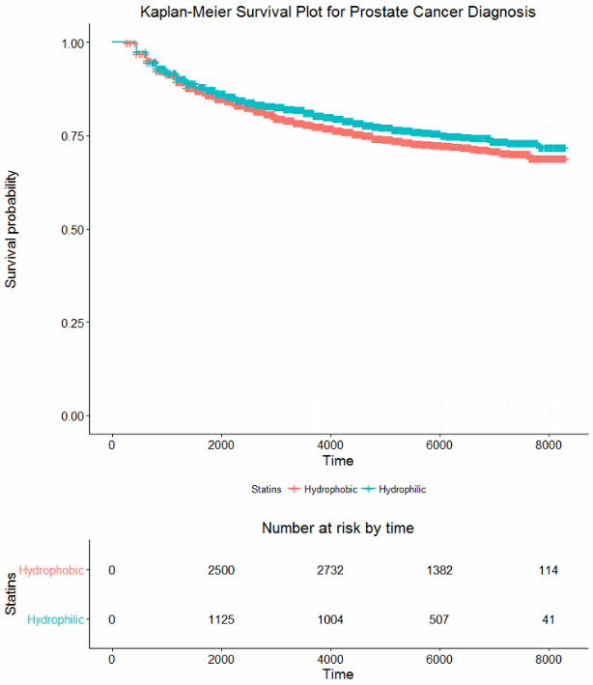

Fig 3. Survival Curve comparing the two Statins with CI

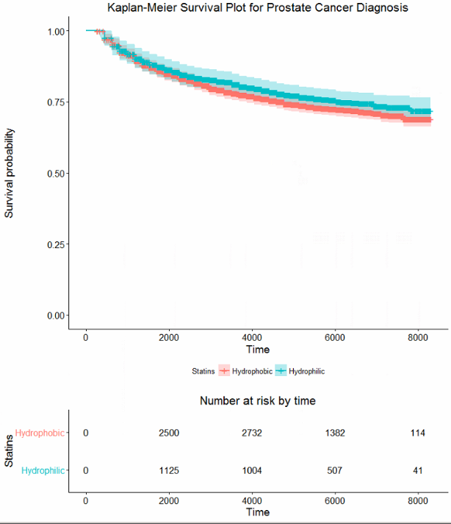

**Statins – OUTCOME: Death**

1. Univariable Analysis correcting for covariates.

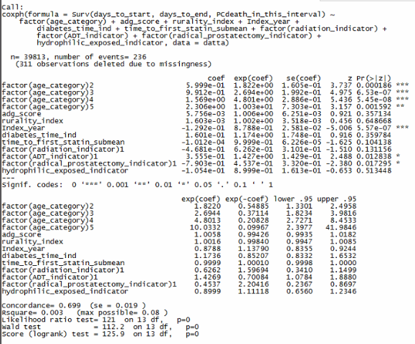

1. Multivariable Analysis.

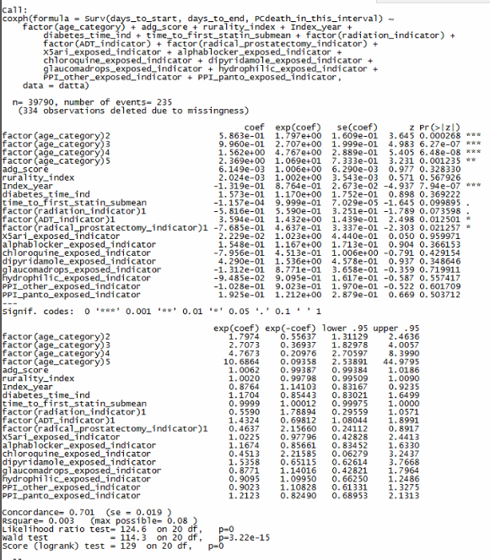

Fig 4. Survival Curve for the entire Statin Cohort

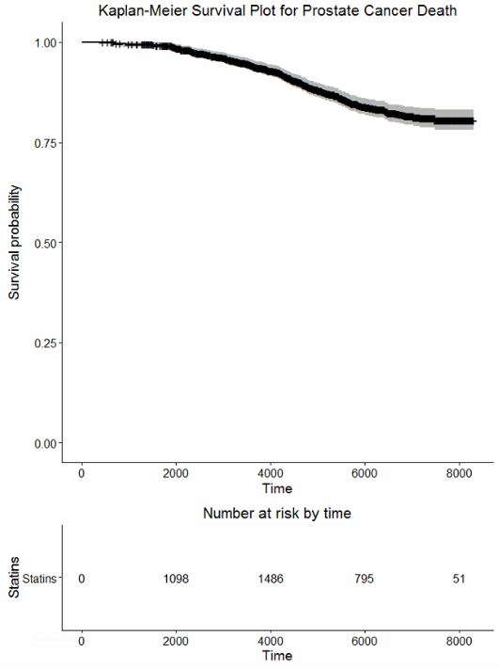

Fig 5. Survival Curve comparing the two Statins without CI

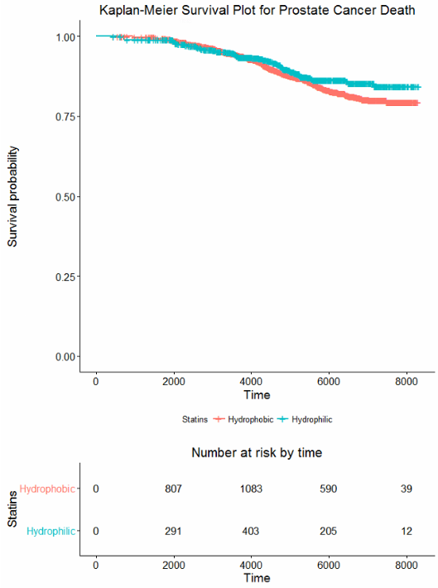

Fig 6. Survival Curve comparing the two Statins with CI

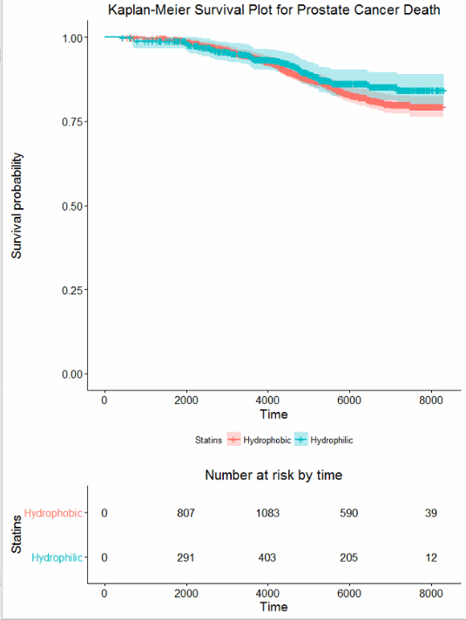

**Diabetes Medications**

**Diabetes Medications – OUTCOME: Diagnosis**

1. Univariable Analysis correcting for covariates.

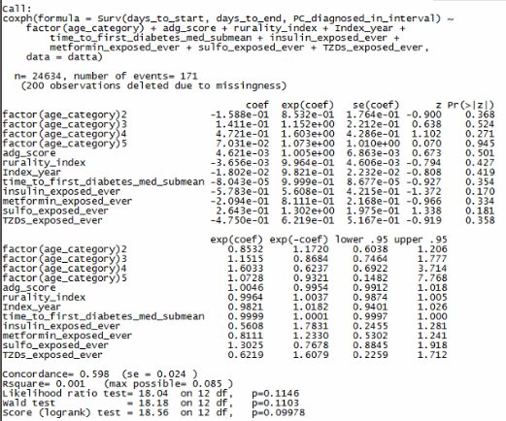

1. Multivariable Analysis.
   * 1. Baseline Model

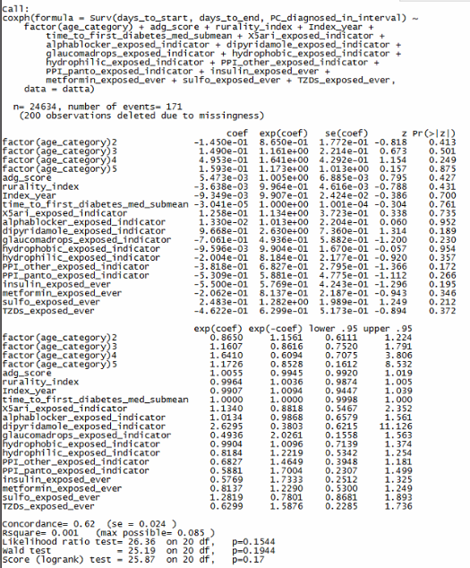

* + 1. Original Model (all variables are time-dependant: exposure status for all the medications can change, i.e. ever vs. never)

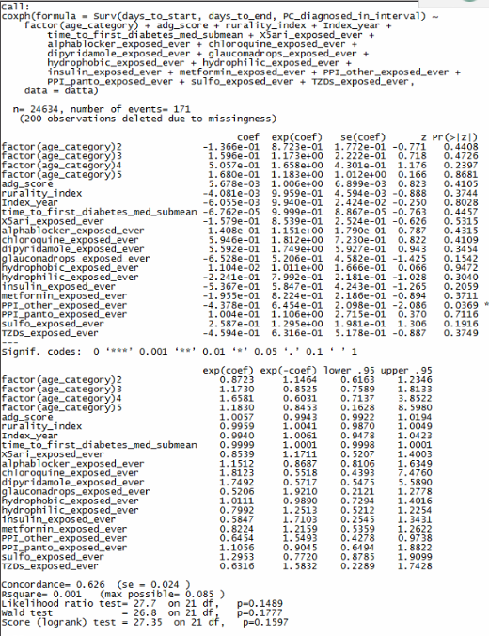

**Diabetes Medications – OUTCOME: Death**

1. Univariable Analysis correcting for covariates.

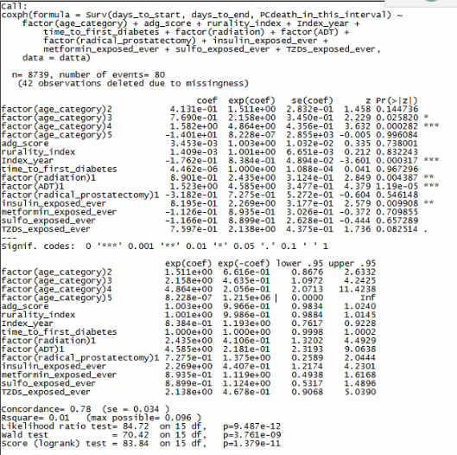

1. Multivariable Analysis.
   * 1. Baseline Model

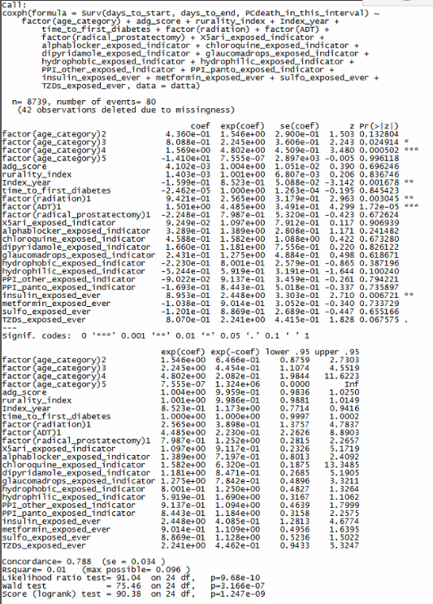

* + 1. Original Model

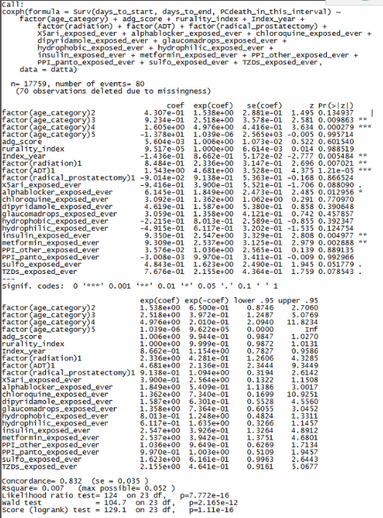

**PPI**

**PPI – OUTCOME: Diagnosis**

1. Univariable Analysis.

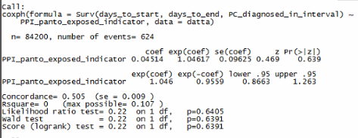

1. Univariable Analysis correcting for covariates.

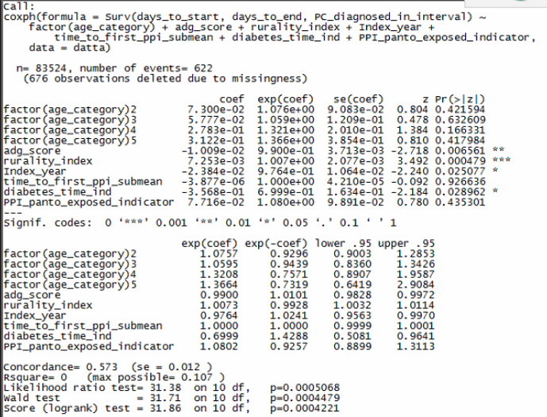

1. Multivariable Analysis.

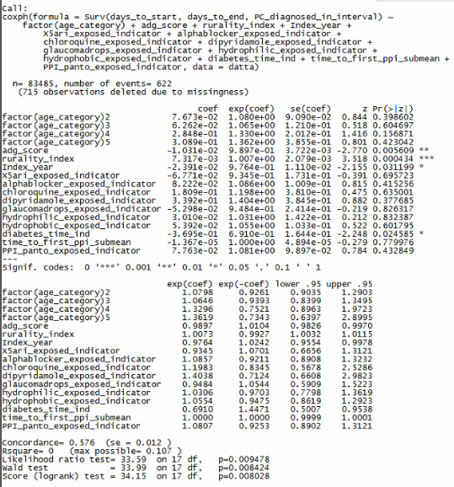

Fig 7. Survival Curve for entire PPI Cohort

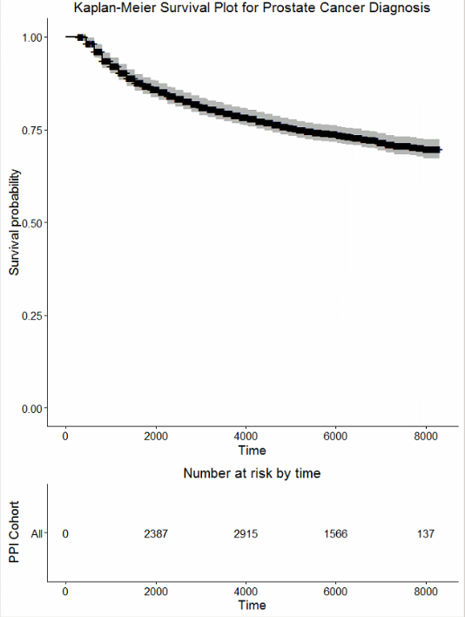

Fig 8. Survival Curve comparing the two PPI’s without CI 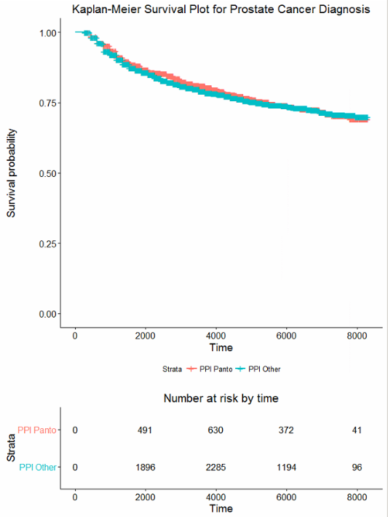

Fig 9. Survival Curve comparing the two PPI’s with CI

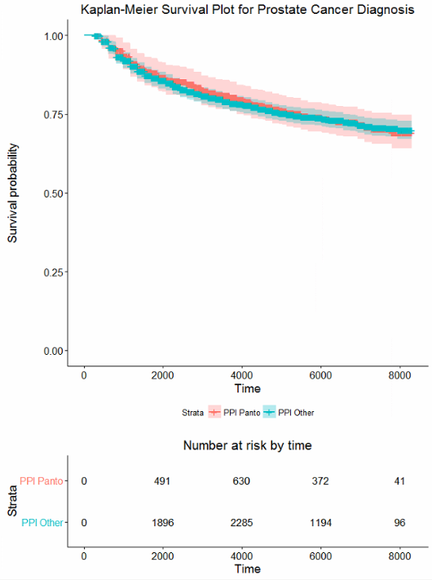

**PPI – OUTCOME: Death**

1. Univariable Analysis correcting for covariates.

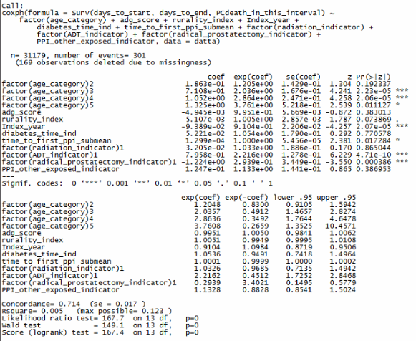

1. Multivariable Analysis.

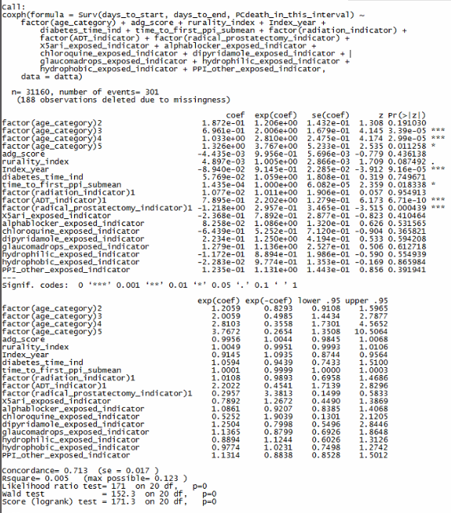

Fig 10. Survival Curve for entire PPI Cohort

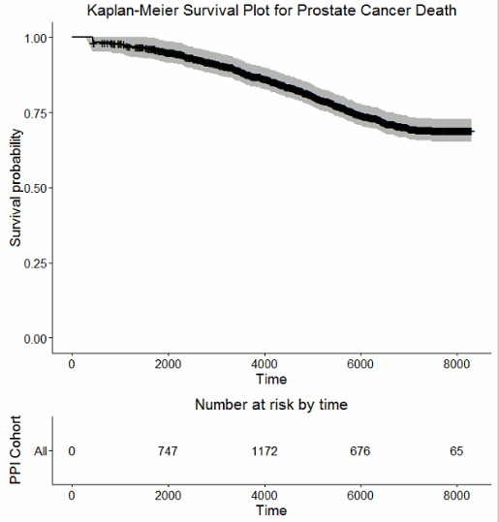

Fig 11. Survival Curve comparing the two PPI’s without CI

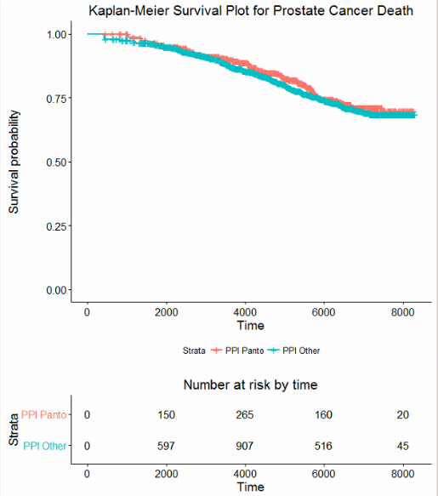

Fig 12. Survival Curve comparing the PPI’s with CI

